TRACCS CLIENT PORTAL MODULE (OVERVIEW) 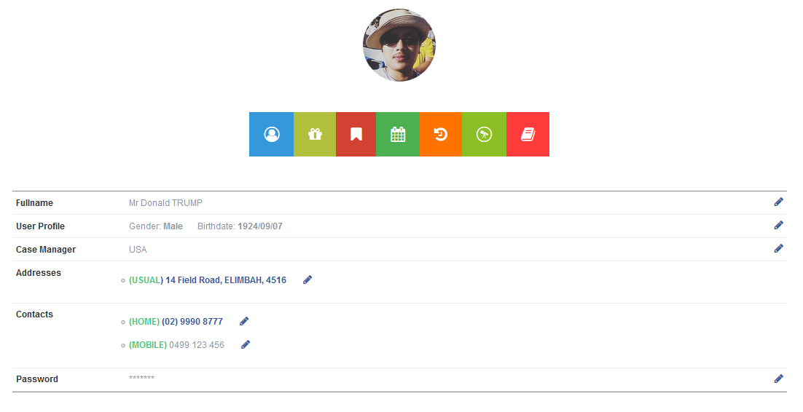
The client portal module in TRACCS provides a user friendly, feature rich environment for aged/disability clients or their carers to
- View and manage basic client information
- View package statements (with print to PDF)
- Place booking requests – either
  - With or without choice of support provider
  - As one off ad hoc or permanent booking requests
- View real time client calendar
- View service history
- Manage clients personal preference list
- Manage existing service requests
  - Cancel pending booking/s
  - Cancel pending service/s
It also provides agencies with the ability to publish informational or marketing material direct to the client in any multimedia format (either individually or by any number of client marketing groups)

CLIENT PORTAL LOGIN SCREEN
Clients access their record via a login set up on registration with the agency
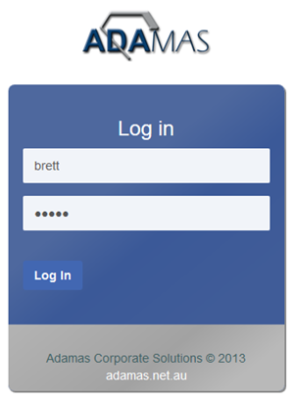

CLIENT PORTAL PROFILE SCREEN
Logging on takes the client to their profile screen which displays a portrait photo and their basic demographic information - where they can manage such things as changes to phones, addresses etc, This main screen also gives the client access to a toolbar allowing access to the other sub modules.
Multimedia marketing or other information is published in a youtube style portal in the marketing sidebar
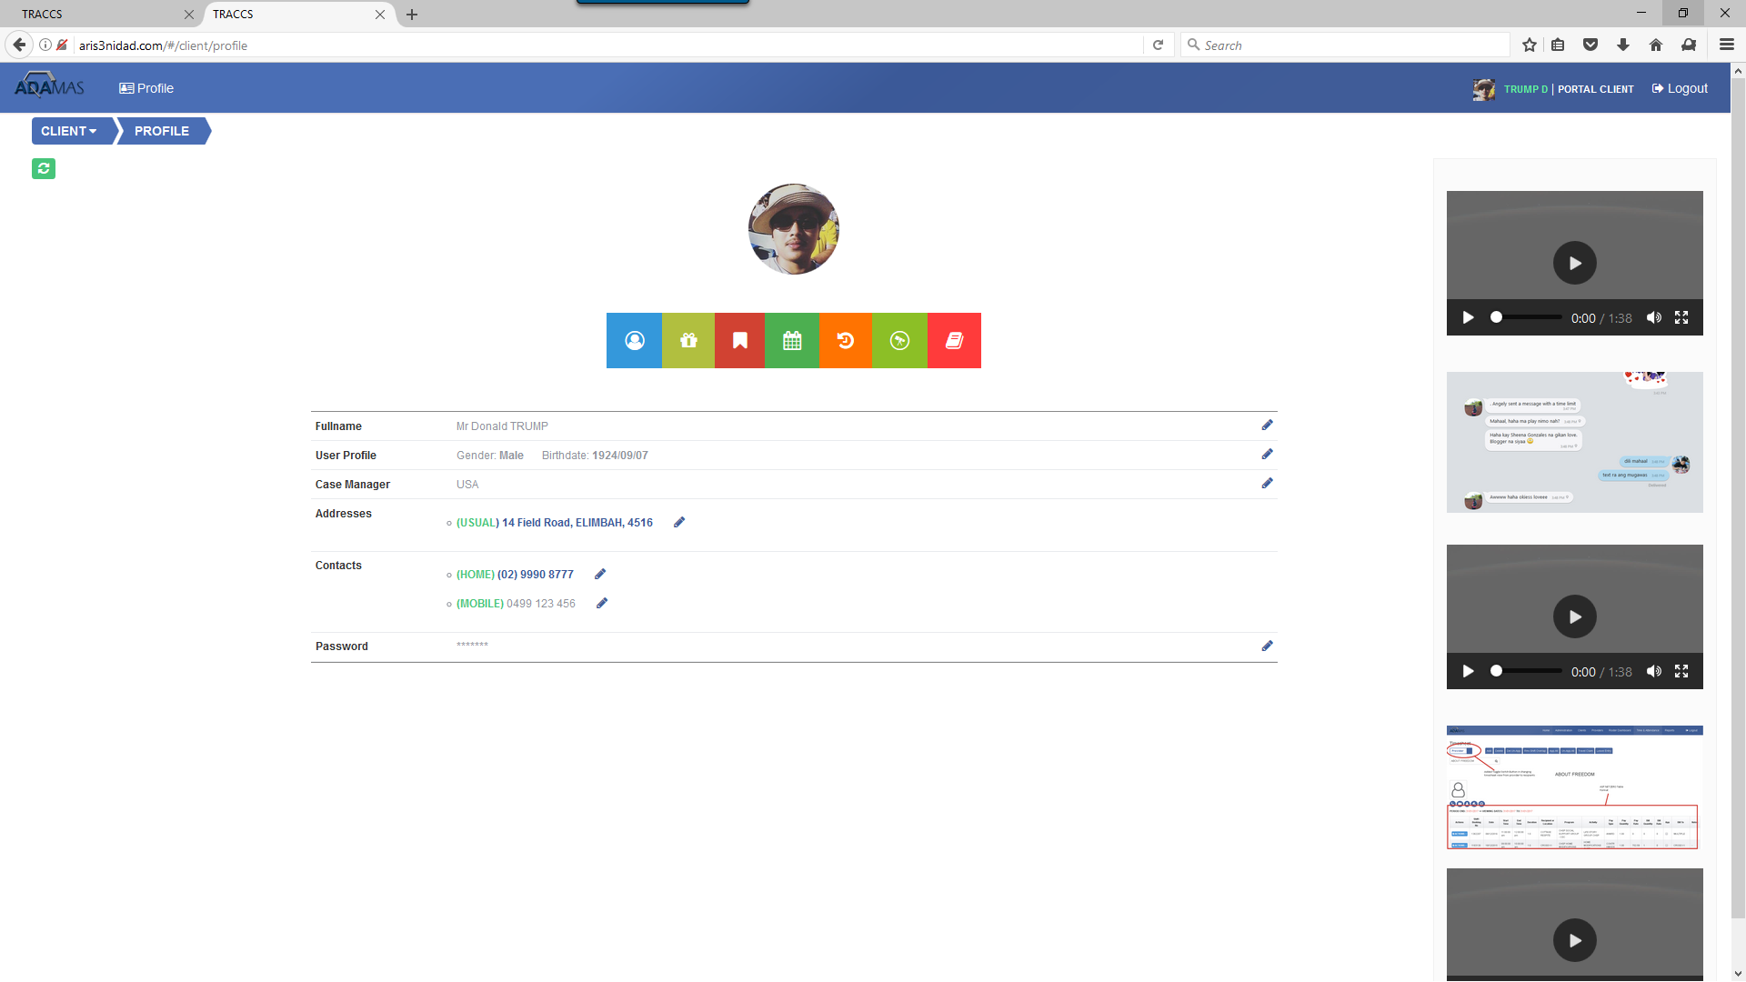
VIEW PACKAGE STATEMENT (AGED CARE, NDIA OR ANY OTHER INDIVIDUALISED PACKAGE)
Clicking the package statement button allows the client to view either past or current package statements for any approved funding the client has through the agency. The client can also print this as a pdf document to their printer.
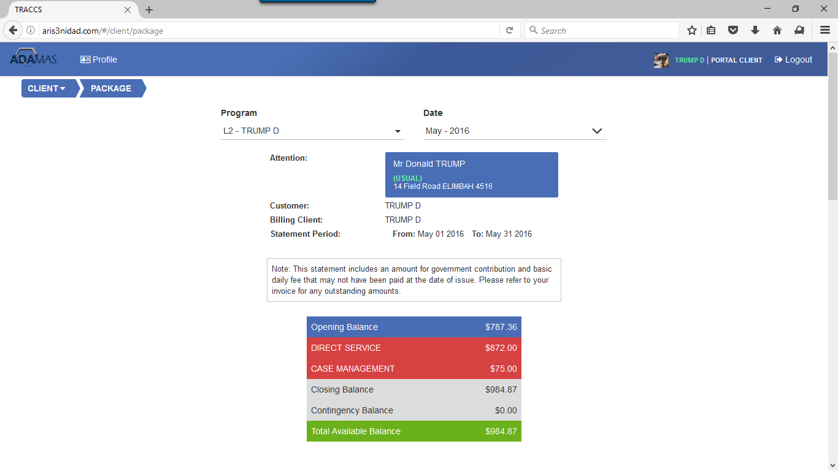
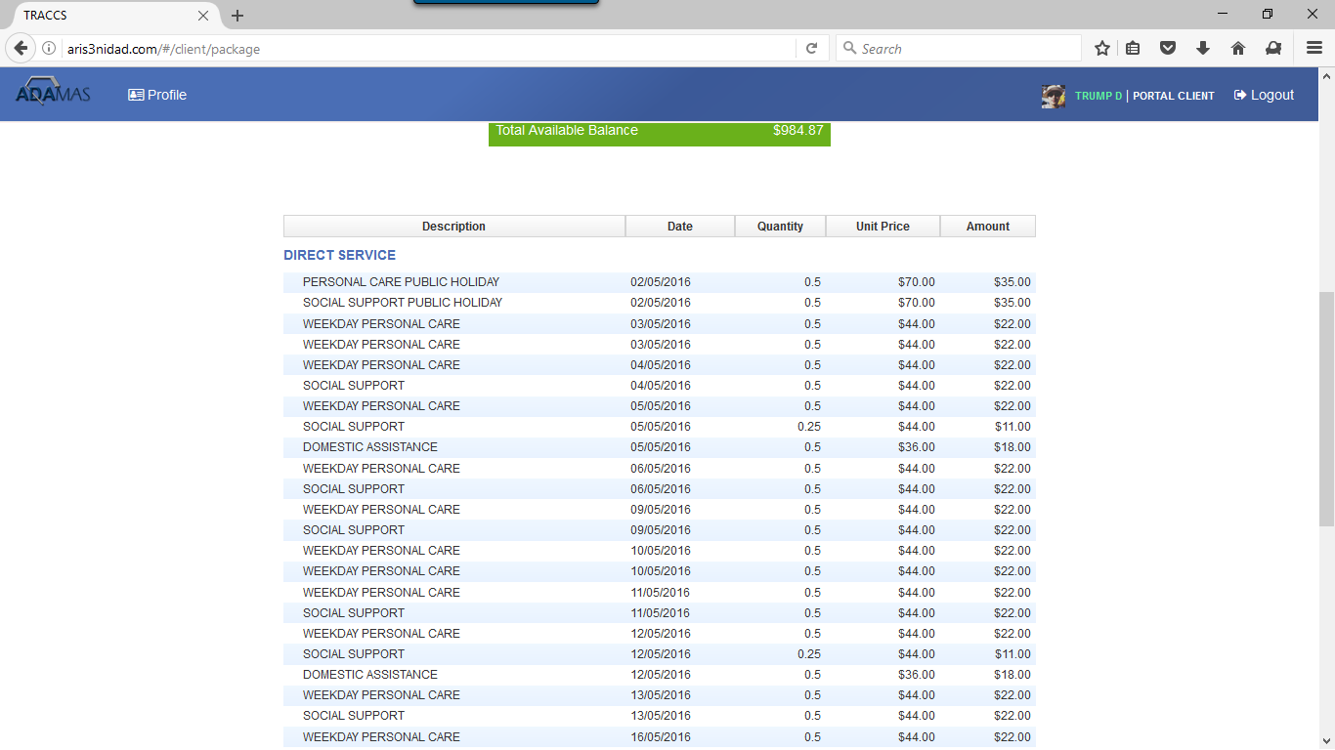
BOOKING REQUEST
Clicking the booking request button allows clients to log a booking request with the agency or direct with a qualified support worker/provider
When initially accessed, the booking request screen shows a shop style display of services that have been approved for the client with an appropriate image or glyph and details including cost of the service.
Select Day And Time of Booking
After selecting the date and time of the desired booking – the client may also elect for this to be once only or permanent
The client can then select to purchase services by clicking on the desired service. The list of services is drawn from the list of approved client services in the client record.
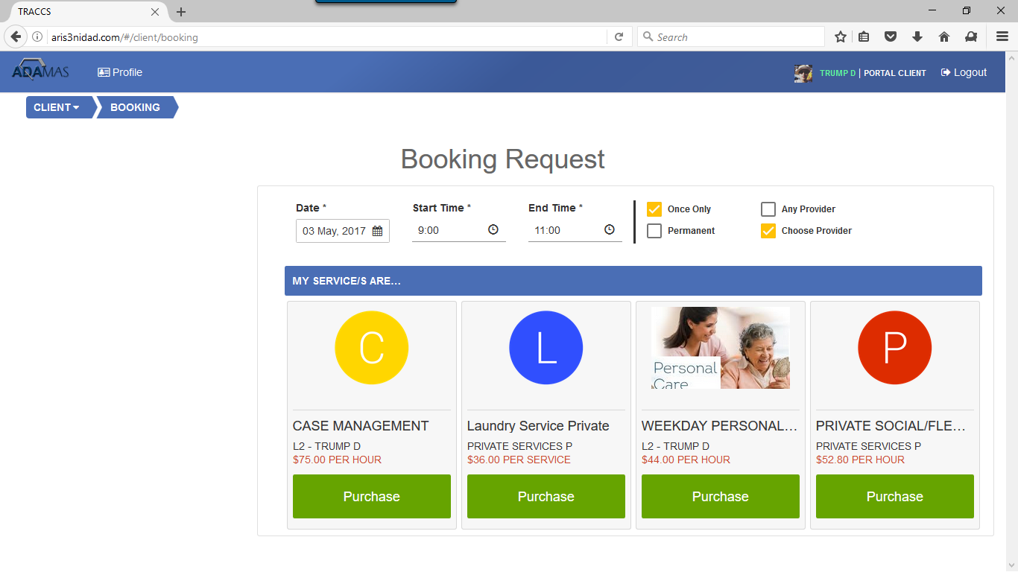
Client Choosing Worker/Provider
Selecting Preferences
After selecting the service – the currently set client specific preferences are displayed. The client has a separate ability to maintain this and change it as required. The client modifies this if desired/necessary prior to looking at a short list of qualified support workers/providers. This interacts in real time with the client record in the database updating any client preferences and merging these with any assigned competency or preference requirements.

Modify Support Worker Preferences
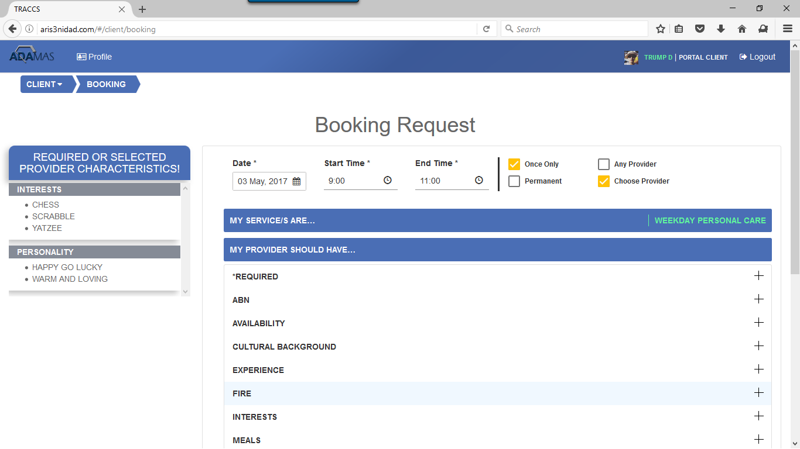

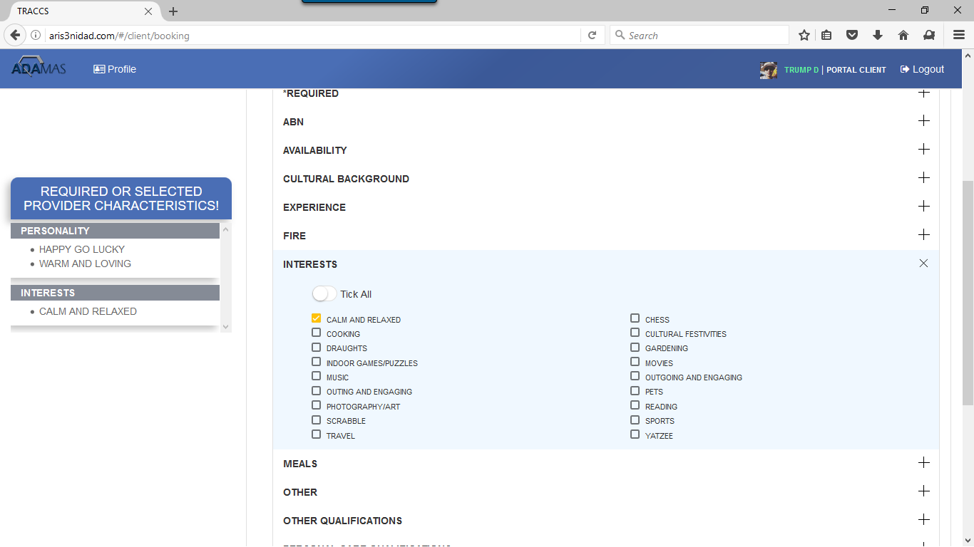

Suitably Qualified and Matched Provider List
After having confirmed any desired preferences – the client clicks Find Provider
TRACCS portal will respond with a list of suitably qualified providers who are available in the nominated timeslot and who have sufficient hours available to perform the job.
The list incorporates enforcement of ALL mandatory and desirable competencies and characteristics across Global, Programs, Client and Client Service Level.
The list shows a profile photo of the worker, the charge rate, gender, age, icon/glyph summary of competencies, annotated list of competencies, an agency defined star rating, an agency defined service medal, a hyperlink to any reviews of the worker submitted by other clients and the distance from that support worker to the client address at the time of the shift.
Nominating a support worker sends an app message to the worker on their TRACCS Mobile App and allows them to accept or reject the booking, and simultaneously emails the roster department advising the client has requested a booking with the nominated support worker
If the support worker accepts, the client is emailed a confirmation and roster department receives an email notifying of the confirmation of booking with the nominated support worker –
The shift appears as a normal allocated shift on the TRACCS Day Manager.
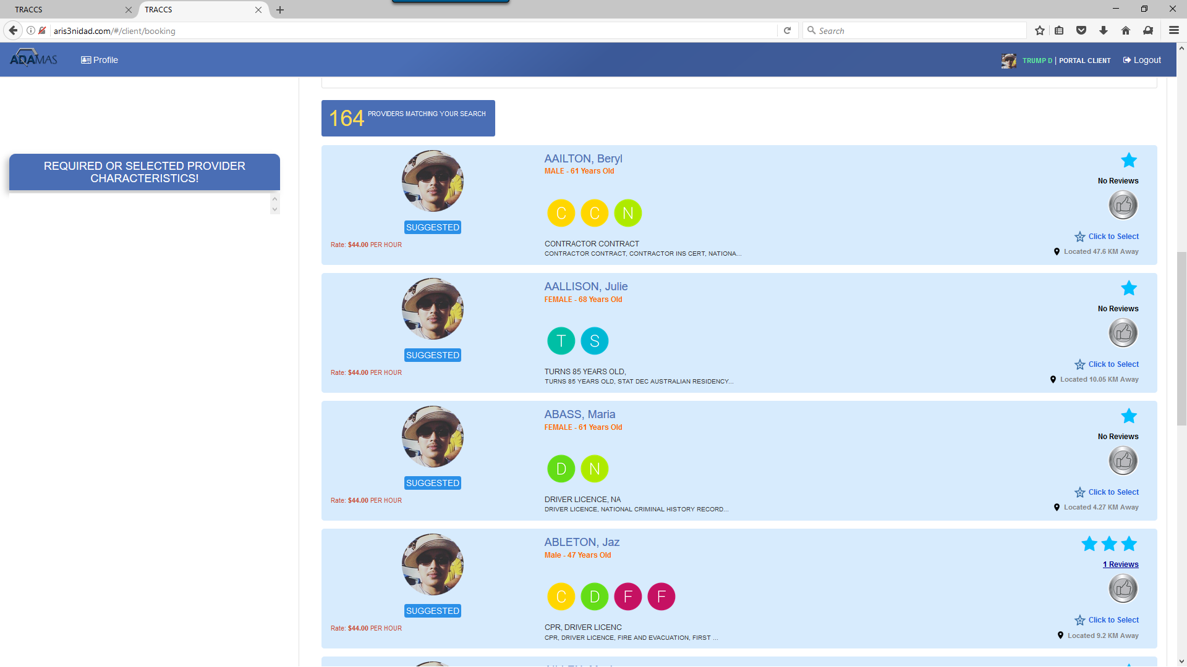

Client Allowing Agency To Choose Worker/Provider
If the client nominates to allow the agency to select the support worker – an email request is sent to the roster department notifying them of the booking request, and the request appears as an unallocated booking in the daymanager for the roster department to allocate as required.
Example Booking Screens
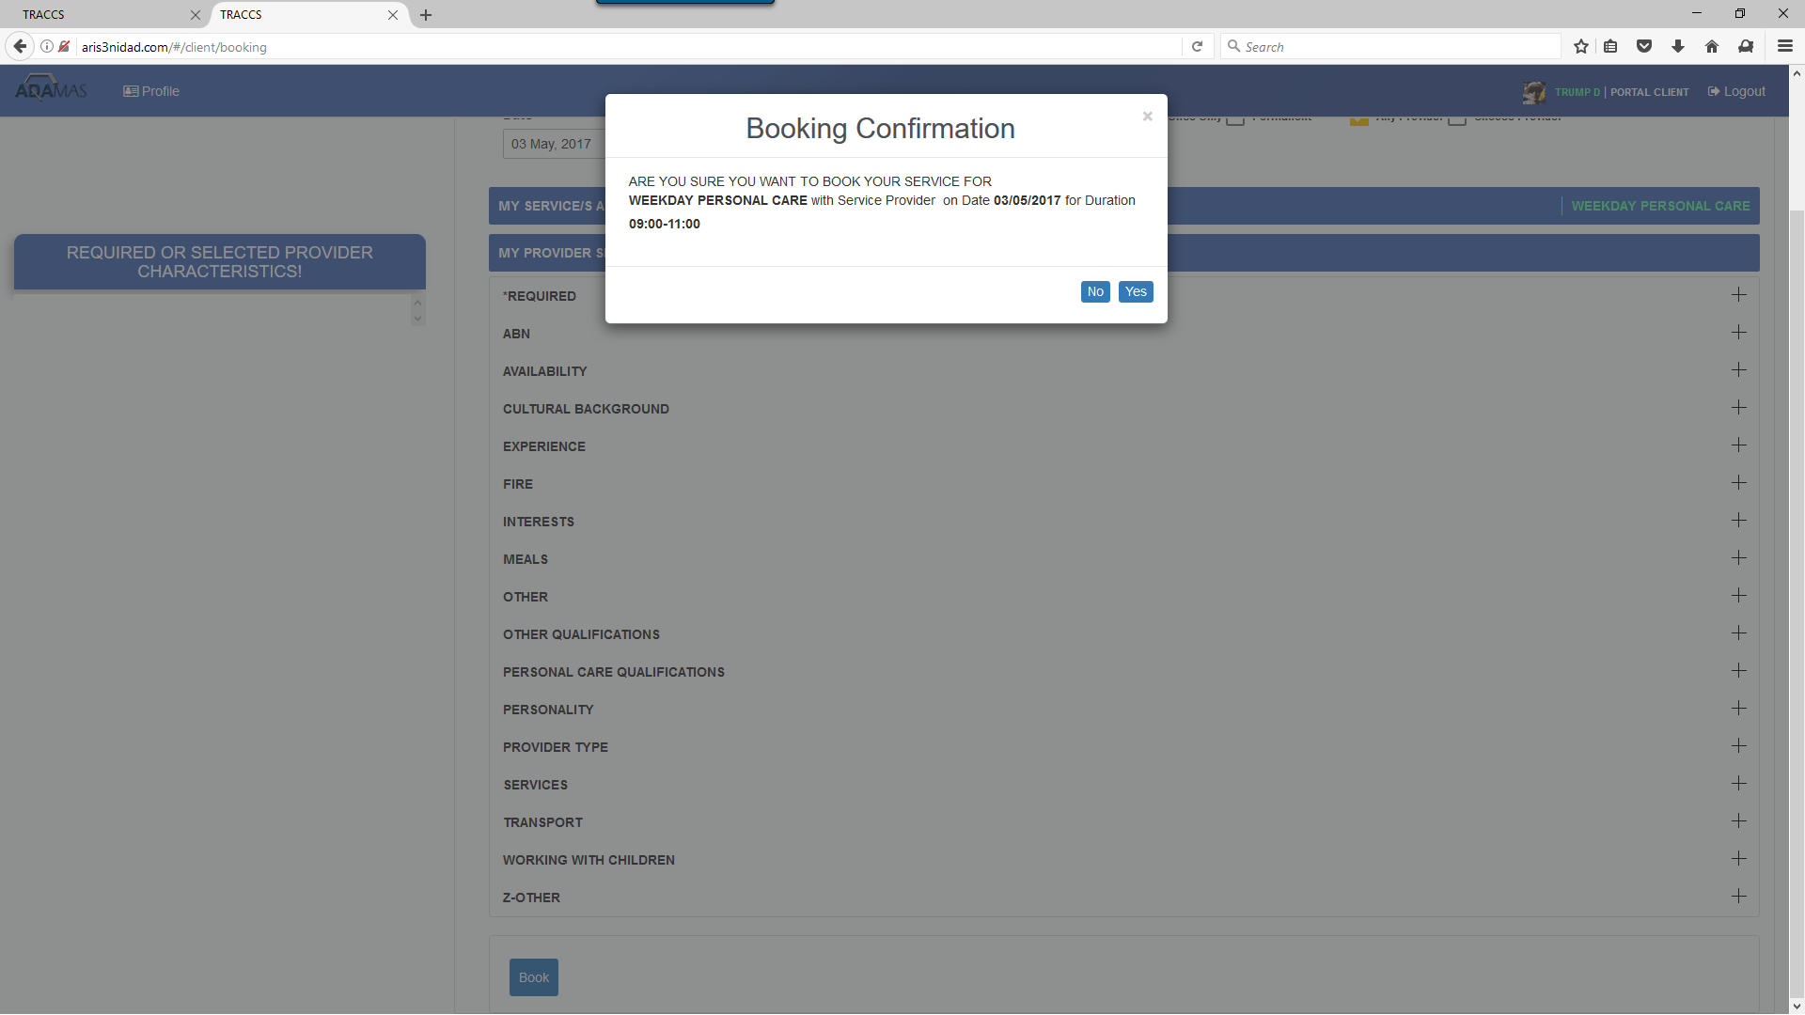
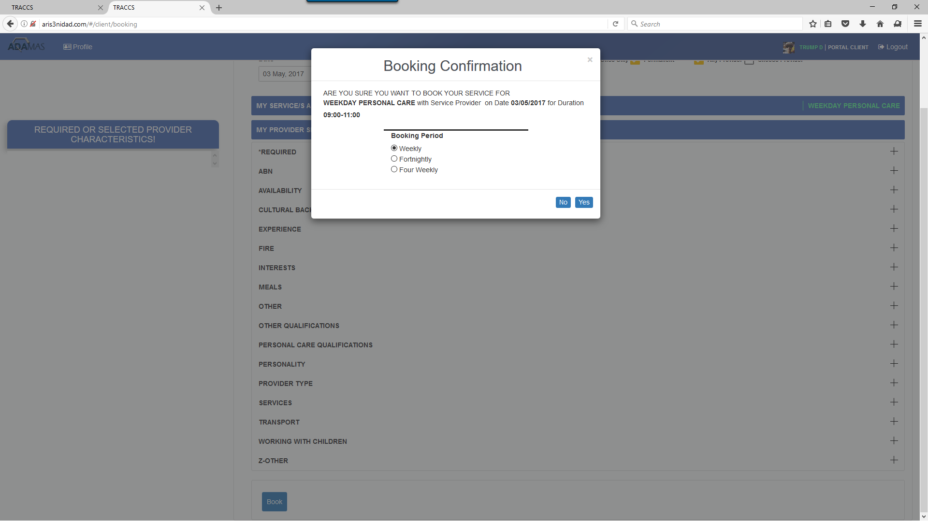
CLIENT CALENDAR
Clicking on the calendar icon allows the client to view a monthly calendar of services scheduled for delivery – the service, day, time and support worker if allocated
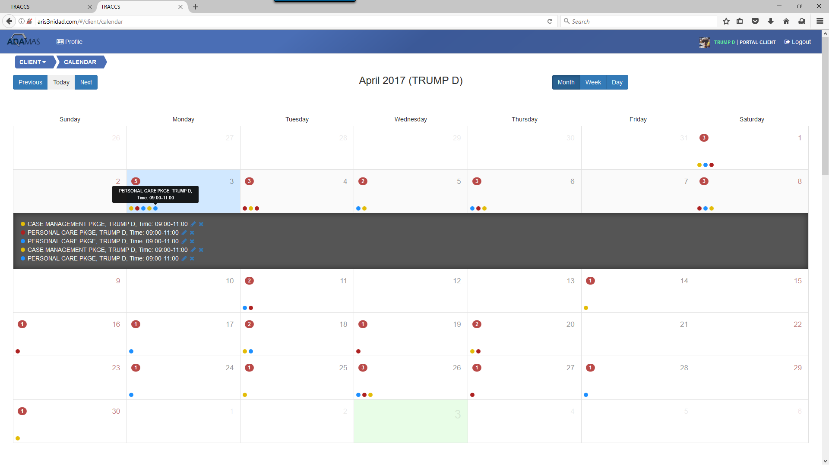
CLIENT HISTORY INQUIRY
Clicking on the History button allows the client o select a date range and view a full service delivery history for that date range.
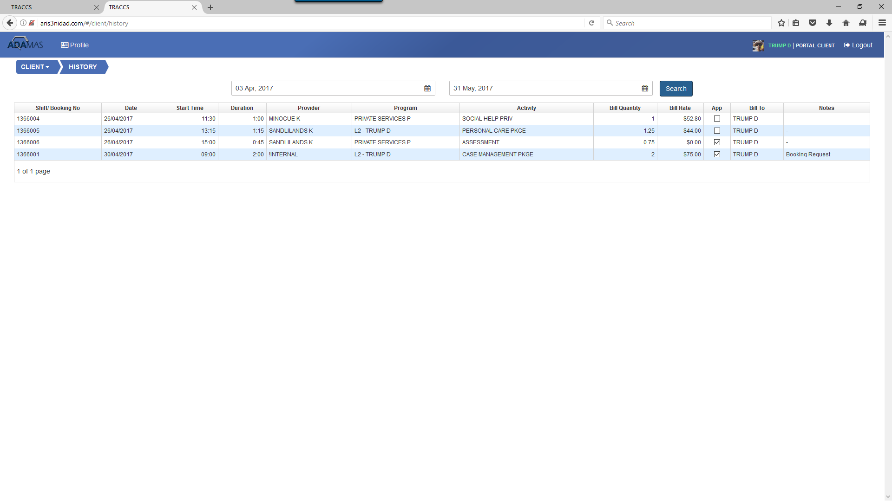
CLIENT PERSONAL PREFERENCE MANAGEMENT
Clicking on the preference management button allows the client to set any particular worker characteristics they would like as a standard default when either they or the roster department is allocating a worker. They have the choice to modify this for any individual booking.
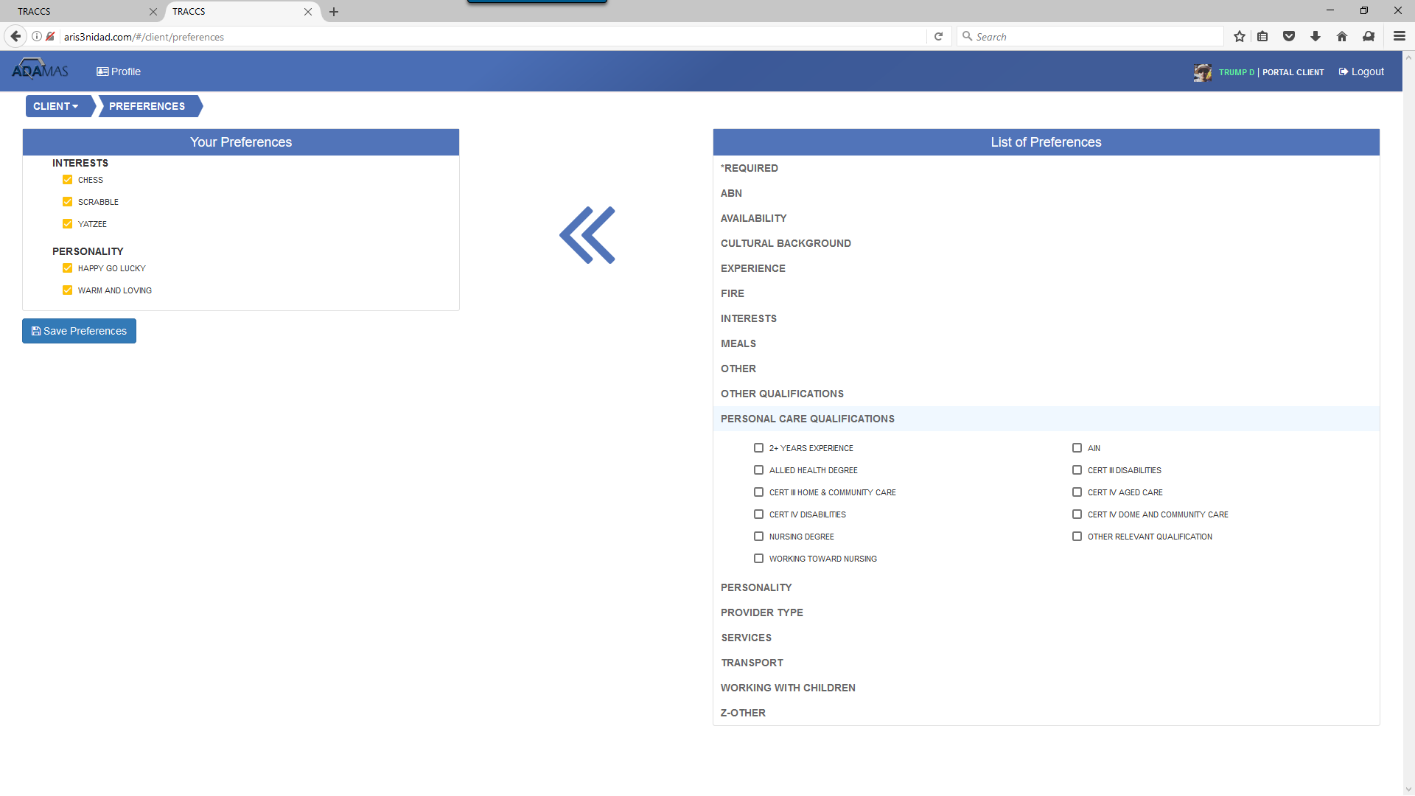

CLIENT SERVICE MANAGEMENT
Clicking on the service management button allows the client to
- Review any bookings created by either themselves or the roster department
- Cancel a booking request
  - Agencies can establish default lead times that block requests with less than a certain number of hours notice
  - Cancelling results in an email to rostering notifying them of the cancellation

- Review accepted bookings (services allocated to a worker that have not yet been completed)
- Cancel a rostered shift
  - Agencies can establish default lead times that block requests with less than a certain number of hours notice
  - Agencies can establish rules for no notice, short notice and with notice cancellations that automatically bill the client for no notice and short notice cancellations. The client is warned when they click the cancel option that charges will apply
  - Cancelling results in an email to rostering notifying them of the cancellation
- Review Completed Shifts and
  - either approve as having been completed satisfactorily by the worker –
  - or lodge a query – which is emailed to the client case manager
- Review Approved services
- Review services the client has queried and approve
- Review billed services
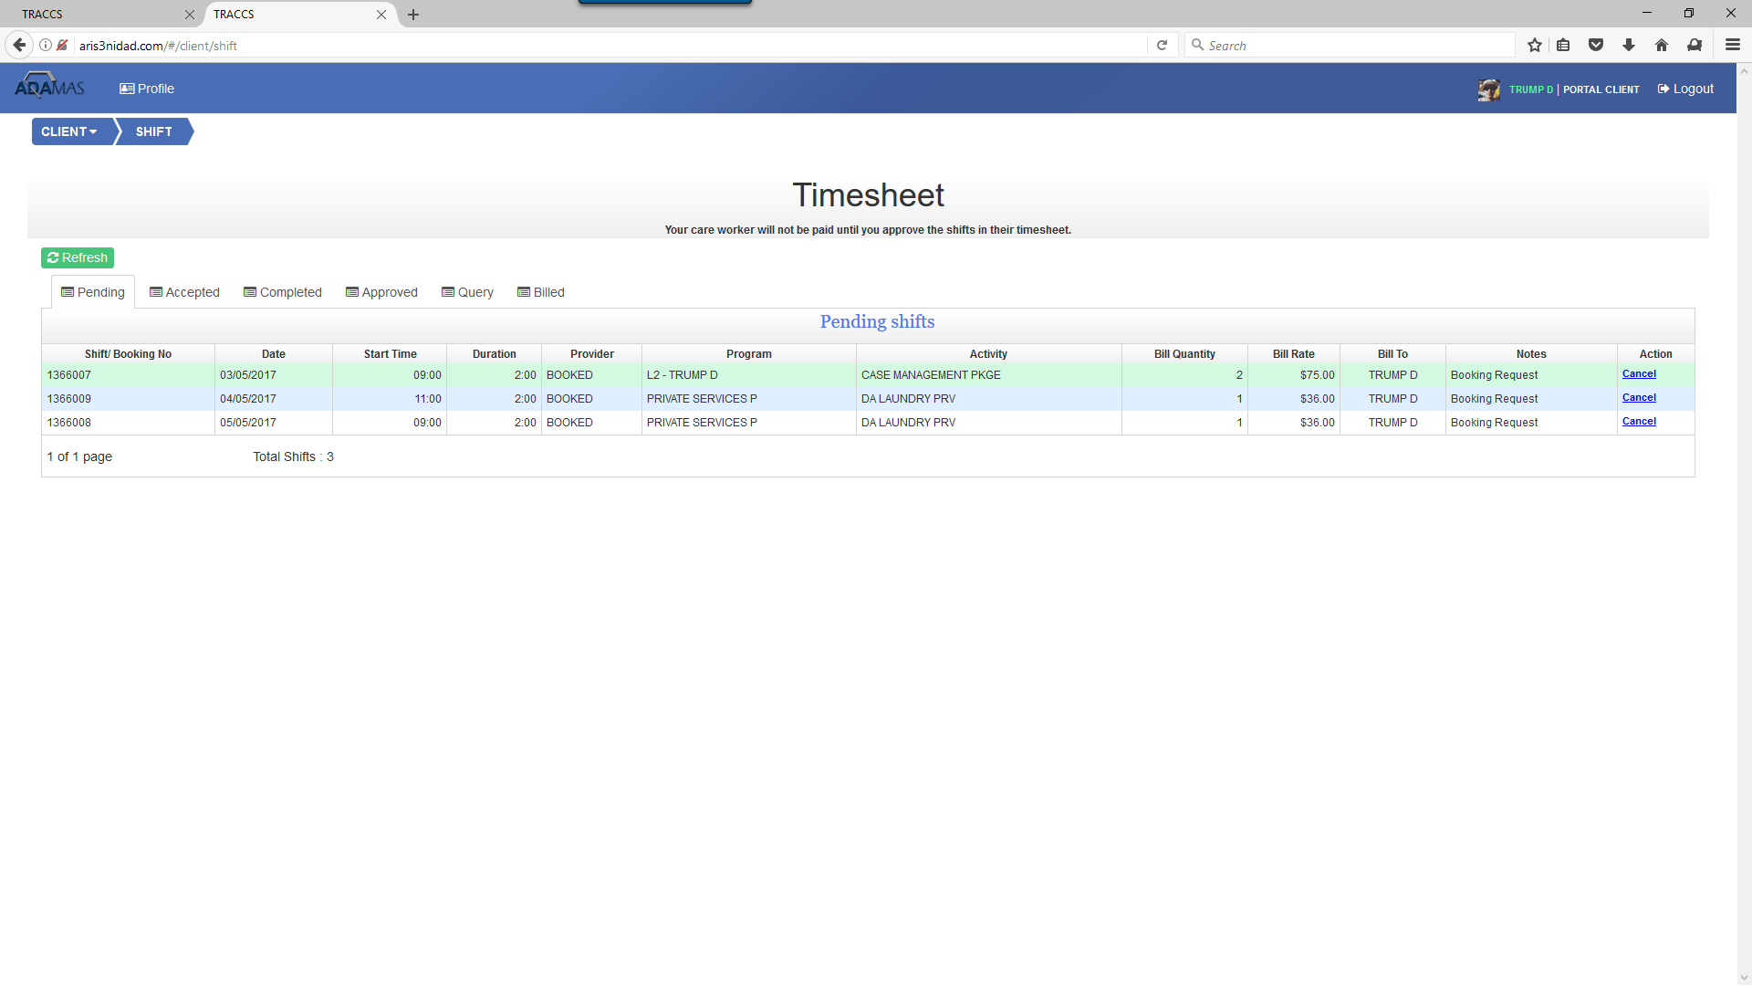
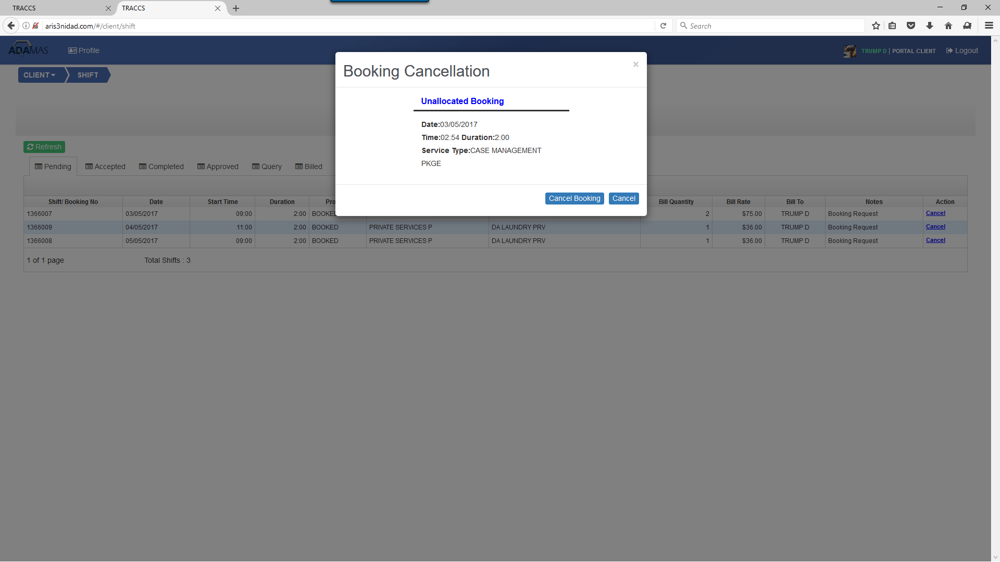For further information about licensing and pricing please feel free to contact sales@adamas.net.au

